1783 An Account of the Boundary Marks round Pirton Parish next to Shitlington, Holwell, Ickleford, Hitchin, Offley

The rogationtide walk begins at Pirton Grange and continues clockwise round the parish boundary shown in red on this map.

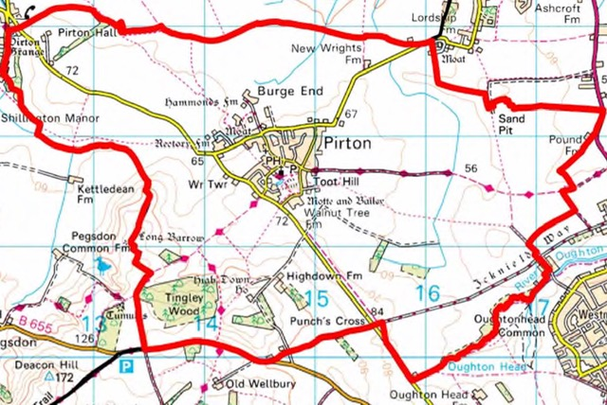

Rackpits upper end and at the lower end by the Waterside and by Mr Hanscombe’s Hedge side next Pirton Field

Mr Handscombe’s Garden just by the apple tree

Mr Handscmbe’s Barn both ends and middle

The end of the lane leading from Mr Handscombe’s Gallos corner and the end of the close next to it.

The corner of the bottom of Long Lacy Northend and Crapols and Howlet Lane

Top of Putteridge Furlong Holwell Field Holwell Common and at the end of Hobbank.

The corner of the hedge at the bottom of Smallbrook

The corner of Pirton Cow Common Holwell Field side

The corner of Water Shire Pikle next the Moat

The corner of the close next Hatch Furlong Bank, the short hedge the top of Low Furlong Catchpole Acre, Rye Furlong at the top. Upper Holylands and Lower Hollylands, Gallo0s Corner next the Turnpike Road, bottom of Long Risden and the top of the same shot

The corner of Grooms Wood and the corner of the Rails leading to the Turnpike

The bottom of Pond Furlong leading to Westmill under the hedge side Westmill Close.

Hitchin Common under the bush by the waterside

West Mill rails before the Mill door Oughton head

The bottom of Lybury hills leading to Hitchin

The corner of Offley Field called Punches Cross

Welbury Road at the bottom of Doghole

Wellbury Road at the end of the lane leading from Pirton to Wellbury

Tingley Wood corner Pegsdon field

Long Eitherwells next Morrows Pikle

The Hedge Corner the other side of long Eitherwells

Nocking Nole and the top of Long Eitherwells the top of Childs Half acre and so down the bank to Rackpitts where we began

May the fifth 1783

The Reverand Mr John Peers Vicar

Mr John Throssell )
Mr Francis Burgess ) Churchwardens

