HALS DE73

The arrangement of the open fields in Pirton before 1574 was two fields East Field and West Field.

- 1595 ordained by this court to the end that memorye might be in what sort the fields were used in times past being two fields that hath being thought good by the lords and tenants of this manor to sette down the order of them.

- The fields were changed from two feildes to three feildes about twentie years agoe by the tenants of the towene and not confirmed att any Court Baron

- When they were two feildes the one field next from Chapmans house in Alton Bottom to the townside and soe to grene chtche and from thence to tingle woode and so in this season was conteyned Witefield and all the lande on that side tingle wood and agane from Mallam Pickle about the waye to the towne, and soe all Danefield and the Claye field, where the windmill was contened even to Wm Hammonde gate at the townes ende.

The other feilde contened norther ende fule the burye feilde and the reddefeild unto the foresaid Chapmans house againes from the town all wood field striking upp by Whitebreeds upp to tingle wood corner, and soe to Mallards pickle.

In these feildes were every yeares land hatch furlong striking uppon the braches, all the croftes betweene William hammnde house and the parsonage gate.

Item Northmeade and one shott on both sides of Northmeade called the hurst and other shotte called golde croft and halemlens and churchewaye breade whitebrede green dyche.

Chappell close and the next close to it conteninge Seaven acres one acre and an halfe which was once William Sammes lyeing in the corner by chappell close and one roode which was sometimes hemmings land and two acres which adioyneth on the other side of the hedge towards the south sometimes Wm Copcotte.

And all ball lande was called Cottermerende hitche ? being three Croppeland and Mad furlong on this side Chapman house was also Cottemerend hitche beinge three croppe land and ball land was and so was grenelow field from bury meade as the Mill path goeth to that waye that goeth to Chapman house (is this the millhouse?) that is beyonde the waye was not hitche.

Further to the Lords demeanes were allowed in Burye feilde or woodfeild for the hitche
one furlong with the appointment of the Lord and his tenants.

In the other feilde a hitche was likewise appointed by the Lord or there tenants in like manner as in the other feildes.

The towne likewise had a hitche appointed in some corner being all together of two or three furlongs.

Item we order and agree with a full assent and consent that Dogholl and highdowne furlong shal lye and be used as parte and parcel of the Danefeild. Item we do likewise order that Rotchistone peece and xxth acres adroynnge to the same next to the towne that they shall lye and be used as parte and parcel of bury feilde.

Item wee that none shall putt any sheepe in the lott meadowes from Ladye daie until whitsontide nor in the common meadows till Midsomer upon paine for everye offence 3s 4d provided that yf the tenants of the other manors agree not hereunto that then this paine to be void.

William Plomer baliff 1595

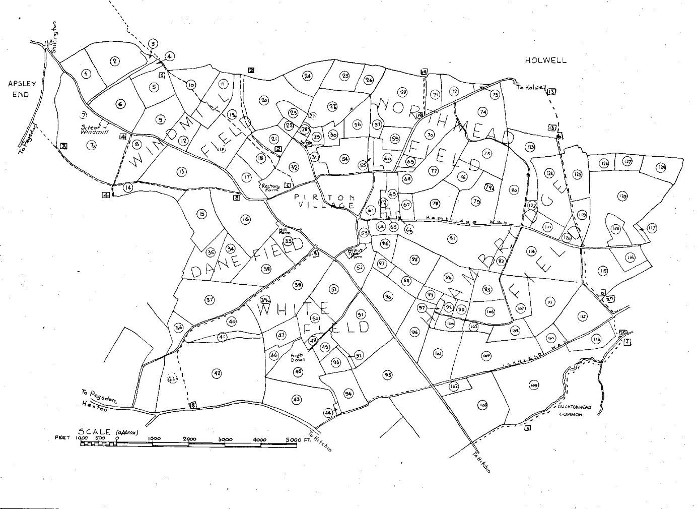

A map of the fields in 1800 showing the main large open fields Windmill Field, Danefield, Whitefield, Hambridge Field, Northmead Field

