# 

--********

***The Building Location***

The house now situated at 79 High Street opposite the Blacksmith’s Pond was bought by my parents, Harold and Jean Massam (née Follington), to bring up their family of eventually three children, of which I was the last.

Harold was ‘not from these parts’ but from the next village of Holwell just a mile or two away and was one of three children.

Jean’s family had settled in Davis Crescent and she was one of seven children. I therefore grew up surrounded by a total of 27 cousins which was totally awesome and at times overwhelming in a good sense as it meant that there were plenty of kids to play with and the bond with them is still strong.

We always thought we were blessed growing up opposite one of the village’s iconic and popular locations, where people would pause and chat awhile and children would play naturally. Some of us and our pets ended up in the local paper as journalists sought to fill column inches in the news drought that was always August.

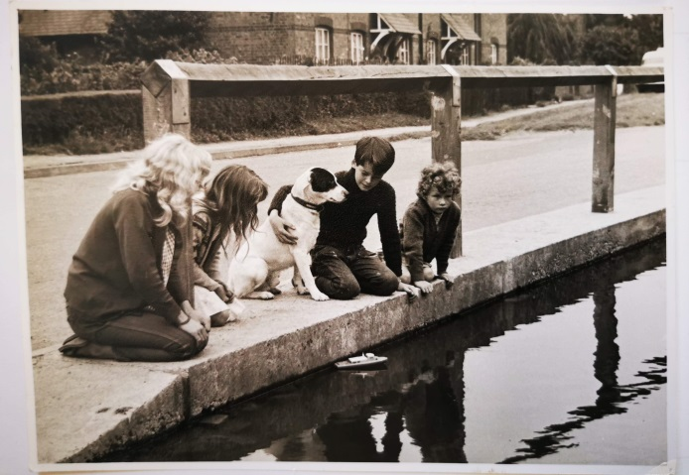

Figure 1: Patch in the papers by the Blacksmith’s Pond

My Dad also impressed on us how fortunate we were to live on the same plot where the Blacksmith had his forge, as the ground all around the house was very dark, fertile soil, produced from the decades given over to receiving the spent ashes from the forge.

This allowed my father to have a seedling vegetable patch out back that always seemed to grow excessive amounts of young winter savoy cabbage, runner and broad bean plants, Brussel sprouts, lettuces, beetroot plants and potatoes of course. This abundance he regularly shared with neighbours and friends from the village to plant in their own gardens or allotments.

Not only was the soil rich, but it was deep. The whole plot stands a foot or more above the ground around it, which you are immediately made aware of as you step up through the green ironwork gate (still present at the time of writing).

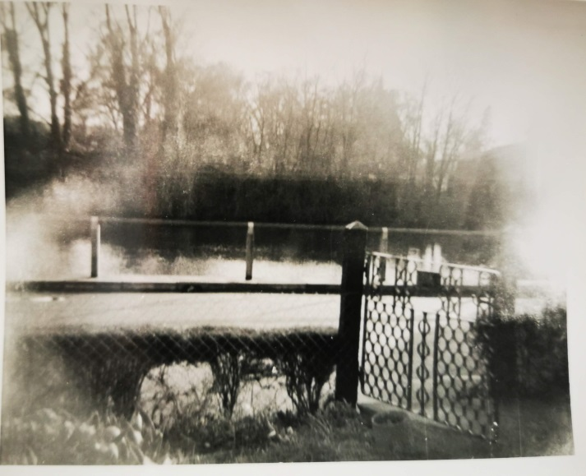

Figure 2: Mind the step down onto the High Street

Again around the back of the house, there are three steps that take you up to what used to be a raised back garden with pond and greengage tree behind. The ashes must have been piled very high.

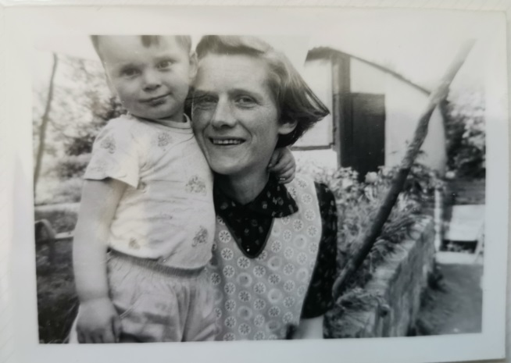

Figure 3: The height of the retaining wall shows the depth of ashes

One impact of this height discrepancy was that the main living room was, and possibly still is, lower than the ground floor, a step down to a room below the level of the window and street above, very private with a snug coal fireplace to warm you.

Another impact from the outside is that the whole house stands proud of the nearby rooftops by that same foot or more. So much so, that the house had been struck by lightning on one occasion (before my time) making a crack down the length of the wall behind the fireplace, where the hastily installed lightning conductor now drops to the earth.

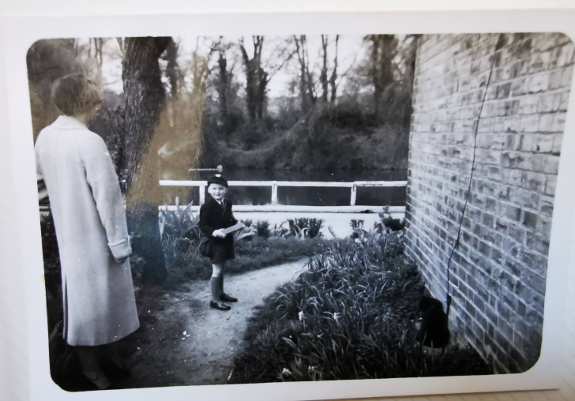

Figure 4: Lightning conductor to ground and one of many pear trees on the left – first day at school, 1964

The trauma of that incident must have been profound, as we were always told to go nowhere near the kitchen or bathroom taps during the many subsequent storms endured. In later years the old pear tree outstripped that conductor by a good few feet, to minimise the threat of the house being singled out again.

To the original two-bedroom house was added a third, in the form of a single floor extension with the luxury of an indoor toilet and bathroom at the rear. Many houses still sported an outside loo. Ours, though decommissioned before my time, still stood for many years after its replacement, harbouring assorted older disused garden implements until its demolition many years after I left the village. It was always referred to as a feature and was the butt of many jokes during family visits.

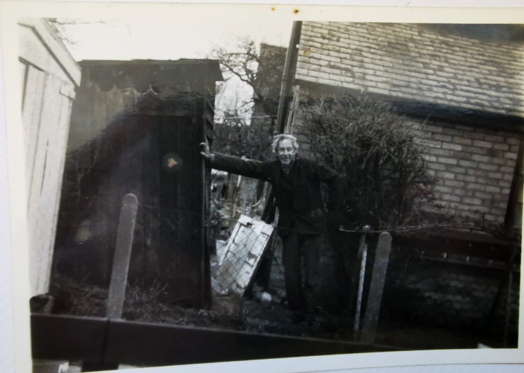

Figure 5: Harold and the lean-to WC

This view is taken from our neighbour’s driveway that was, as I now understand it, the original site of the smithy. An extremely curious coincidence as we always knew him as ‘Smithey’.

The view from the front of the house over the pond was forever changing with the seasons. In full leaf under the elms and with lilies stretching as far as the eye could see, under the willow tree towards the far end where a spring was thought to be, it was an inspiration for young boys. The pond had a healthy population of great-crested and smooth newts with tiny stickleback fish darting in and out from beneath the lily pads. The shallower multiple ponds in the Bury and moat spilling out into its overflow pond housed the same newts and possibly palmate newts too. The pond waters were sometimes coloured scarlet by huge amounts of daphnia swarms.

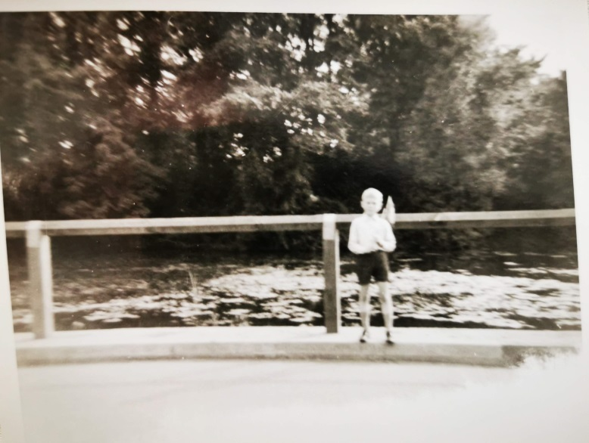

Figure 6: Armed with stocking nets to catch daphnia

At the time they were said to be a sign of a healthy aquatic environment as well as a source of nourishment for goldfish and other crustaceans. Modern science implies that this may have been due to the stress of excessive leaf fall that inundated the pond floor. A little too much for them to handle perhaps.

The surface was frequently frozen in winter and used as an impromptu ice hockey surface with pucks made of ice and the odd branches for sticks. The two resident swans, and later on mallard ducks, fell foul of the ice — one being trapped in a particularly harsh winter, the other recuperating in front of the hearth for a while before succumbing to its chills. A harsh lesson in life.

The pond at that time was still open to the road at one end, where horses would have been led to drink, as some travellers’ ponies did.

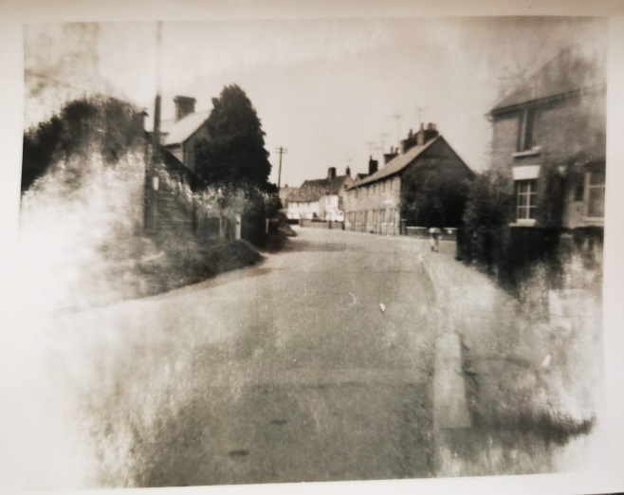

Figure 7: View down the High Street from 79

The view down the High Street shows Darkie Titmus' hardware store on the right (a veritable treasure trove for young eyes to wonder at) and the entrance to the newly constructed Cromwell Way London overspill estate with Cromwell Farm house visible on the right and with Milner's pork butchers building on the left.

His shop front was one to wonder at because of its large bay window and once inside, the sound of the ham slicing machine in repetitive action was mesmerisingly captivating to a young child.

These later photos, taken when an island had been added to the pond, show the open-ended pond and its icy livery in glorious technicolour, converted into postcards.

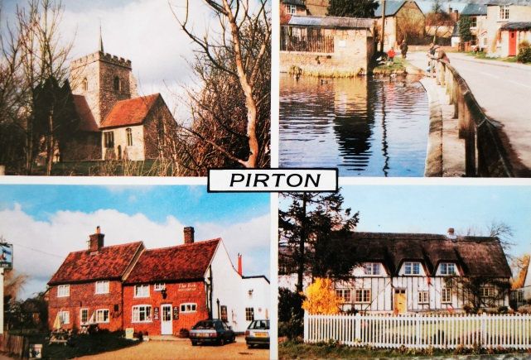

Figure 8: Pirton postcard of village sights

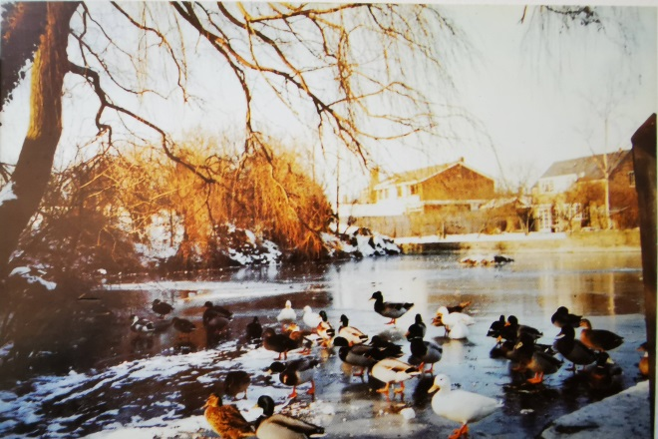

Figure 9: Blacksmith's Pond frozen over

***The People connected with the Building***

My mother hailed originally from Epsom and was a clerk at Barclays bank in London, while my father was born in Poplar, London and became an engineer.

The people associated with the home were Nurse Baldwin, the district nurse who delivered me in the upstairs bedroom as a home birth. The local hospital where children were normally born was Foxholes on the road to Hitchin.

Doctor Goulder was a regular visitor to the house as I missed the first two years of primary school through illness, either stepping through all the childhood illnesses one by one concurrently or being caught up in a severe bout of bronchitis. The overriding impression of such days was contained in a solitary object that burned through the night with a wish for its comforting light never to be extinguished. The scent of Wright’s Coal Tar soap, as the sole survivor of what was ‘Wright’s Coal Tar Inhaler and

Vaporizer’ with the badge of poison writ large across its liquid bottle, remains a source of comfort to this day.

Mrs. Chamberlain next door was sometimes seen ducking under the enormous Bramley Apple tree to hang washing out. A lady who lived well into her nineties, asserting the cause of her longevity to be down to the single bottle of Mackeson that she religiously consumed every day!

There were of course an inordinate amount of public houses from which to procure such things, since the relaxation of the licensing laws in the late 1800’s.

Indeed, that top part of the High Street boasted three within the radius of 100 yards from the only surviving one, The Fox to the Red Lion on Crab Tree Lane to the Live and Let Live next to Hilda Hanscombe’s set back off the road opposite the village hall. It had the dubious distinction of serving me my first shandy, seated outside as was only right and proper with the ladies, while the inside was the preserve of the menfolk. A quaint, but outdated notion that gladly no longer survives in this neck of the woods.

It was at Hilda’s that my father secured a second allotment that was part of an understanding to convert four ex-chicken runs into manageable garden and allotment spaces. The main feature in the re-created orchard being a magnificent tureen-shaped apple tree of the ancient variety and marvellously-named Peasgood’s Nonsuch,

distinctive not only for being able to be eaten raw or used as a cooker, but also having massive apples to boot.

The other person who was not from these parts either, but who had an enormous impact in the village, was a resident of Stevenage who travelled from there to Pirton in a Wolsey (I believe) every school day. That was the illustrious headmistress, Miss M.B.G. Farris.

Miss Farris wasn’t given to having photos taken of her, but this one was furtively snapped of us on a Year 6 trip to London Heathrow (LHR) after its renaming and while construction of terminal building was still underway. We would have to wait just 10 more years before Concorde flew at 4pm every flight day from there.

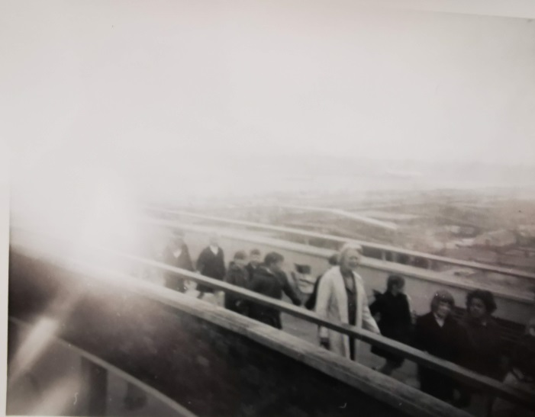

Figure 10: Year 6 Trip to LHR in 1968

The indomitable Miss Farris never gave up on her school or her pupils. Even during the worst winter in 1963, hers was reported to be one of the first cars to make it through deep snow-drifted roads.

A magical place is Pirton, framed as it is in a triangle in a beautifully unique location at the end of the Chiltern Hills, with masses of history to explore.

I count myself lucky to have been born in that house where I lived all of my youth and where everyone knew most people. Yes, back doors were left unlocked all day but the bolt was slid across at night all the same. A cup of tea was never far away, nor was a helping hand to those who needed it.

I look forward to reading more contributions from other villagers.

Yours gratefully,

Peter Massam

Pirton born and bred

***Everyday Life in the High Street and Pirton***

Life growing up in the sixties was full of change, but the rudimentary household items considered now to be commonplace and essential were termed as ‘mod cons’ (modern conveniences) and certainly not within the budget of most households.

The kitchen was known as the ‘scullery’. Its red quarry tile floor was easily washed as it needed to be because that small area was used for washing clothes, bathing children in a small tin bath, cooking, washing up and drying dishes, storing pots and pans, cutlery and crockery and was the access point for the two upstairs bedrooms via a stair door that couldn’t be opened at the same time as the back door.

As children you were expected to help out, taking turns to wash, dry the dishes and put them away before ever thinking about going out to play.

The washer was no less than 2’ square, having an integrated mangle on one side to wring the clothes as they were pulled from the main body of it. I am loathe to call it a ‘machine’ in the modern sense of that word, but it did have an electrical connection to heat the water. Bedsheets were very challenging – too large for the washer, they needed to be heaved from handwashing them in the sink, wrung out by hand and taken outside quickly to hang up on the clothes line before they dripped on the floor. Fine in summer, but in winter they were draped over a clothes horse in front of a coal fire, blocking out that essential source of warmth from the rest of the room and the family.

Sunday was always eagerly anticipated as there was always roast to look forward to… and dessert too. In winter months this would often be preserved fruit, lovingly boiled after the harvest of pears and apples, ladled into Kilner jars with water and sugar to make syrup and stored in the larder.

That small cubby hole was part of the extension and was necessarily cold from the three or more airbricks at the bottom of the outside wall. All foodstuffs were kept in the larder, replaced these days by a fridge.

All of the rooms in that extension had hard tile flooring – not as cold as the kitchen quarry tiles for sure, but it was always advisable to wear slippers, often a coveted Christmas present.

The sunken main room sported a well-worn carpet that didn’t quite cover the whole floor. Wall to wall carpet was a long way off.

Entertainment after Sunday lunch was to sit round the radio as a family next to the fire and listen to comedy broadcasts, namely ‘Round the Horn’ followed by ‘The Clitheroe Kid’. There seemed to be almost an unwritten rule that no child would come knocking on the back door asking us to go and play until these two programmes had finished and all the dishes had been put away.

There was no television till a black and white cast-off had been donated by a kind family member. When it did arrive, there was only one channel allowed as the commercial channel Anglia was thought unsuitable. The second main broadcast channel was introduced with 625 lines of picture across the screen – a vast improvement from the initial 405 lines that frequently were disrupted by irritating buzzing noises and screen distortions as a result of motorcycles going past without suppressors. The law that made cars comply but not motorcycles was the bane of many lives trying to peacefully enjoy the new media.

Getting in contact with anyone outside the village was by a single public telephone, located on Crabtree Lane. There was never a queue. Boys would amuse themselves by trying to conjure up free calls, convinced that pressing the hook many times would allow them to dial numbers. They were not wrong in fact. Pulse dialling was around for a long time, but their knowledge was founded on trial and error for the most part. Coins and pressing buttons A and B were the reliable way.

Between villagers there was no need for a phone. We talked to each other, all the time and yes, everybody knew everybody.

The main sitting room was a main congregation point for all kinds of activities crammed into a small space. Ironing, drying clothes, the oval extendable table with spiral legs that served for all meals also boasted dressmaking in the evening and sundry entertainment—not only the radio on Sundays, but card and board games like whist, rummy, cribbage and of course monopoly, quickly assembled and disassembled jigsaws to free up its next use, dominoes… to name a few.

Music entered these same walls through the purchase of a Dansette record player (nothing was to be bought on the ‘never-never’ insisted on by both parents, known later as hire purchase) and to celebrate its arrival the first album bought with it was ‘With the Beatles’.

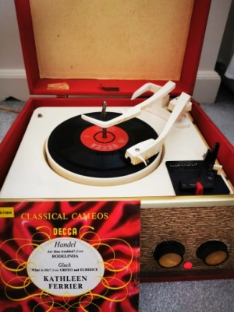

Figure Dansette record player with 1946 recording of What is Life?

It took pride of place on top of an arguably altogether finer piece of furniture in the form of a walnut cabinet Singer sewing machine, used for Mum’s dressmaking and sundry repairs. Beautifully kept and maintained, it radiated quality as the sun’s rays glanced its side.

In fact, during a resurgence of interest in home sewing in the last ten years, I found it a happy seamstress home to go to, complete with instruction manual, oil container, cotton reels, bobbins and needles just as Mum had kept them tidily in the semi-circular drawer on the inside of the left door.

There was a lesson to take away here in that both items were worth the investment because of the quality and longevity of the pieces. Saving and spending money wisely were life-long lessons.

Musical favourites in the house varied of course. One reason for buying the player were the small number of dust-covered 78s (that is, large shellac gramophone records spinning at 78 rpm) that had been given to my parents by theirs. Among them were the lyrical trumpet solo of Eddie Calvert’s ‘Oh, Mein Papa’ and the exceptionally talented Ronnie Ronalde’s ‘In a Monastery Garden’. More daunting were the four records with pink centres with the recognisable and lovable dog listening to His Masters Voice, devoted to a ‘Slaughter on Tenth Avenue recorded in 1937.

It was perhaps not coincidental that at age eleven, I came home to find a puppy that turned out to be almost identical to that dog portrayed on so many records. We called him Patch.

However their musical tastes had evolved to include Kathleen Ferrier (possibly the most gifted contralto in the house and certainly on a par with a personal favourite in Karen Carpenter) and Lonnie Donegan for my Dad, contrasted with Jim Reeves and lovely duets from Miki and Griff for my Mum.

Another enduring record which I keep to this day is a rather special recording sent to my great-grandmother on her birthday (13 March 1942) from my great aunt Minn who was an opera singer and had migrated to Canada. She had found love when visiting Epsom hospital to boost morale among injured soldiers, one of whom was a Canadian soldier. Her sister accompanied her, my Nan Marian Ellen Follington (née Lumley), who found the same with an Australian soldier, Charlie Follington.

The warmth either from sunlight streaming through the main window or from the roaring coal fire made that sitting room a popular one, but another useful addition in the extension was the bathroom at the rear.

The attraction here was not the bath—in which Matey bubbles could be encouraged to reach the rim with enough vigour or the inside toilet—but the electric immersion heater that had to be put on at bath time. Not just the extreme warmth the metal container produced but its height, at about 4 foot tall (4’ or 1.5m roughly) permitted a young boy to sit on a towel on top of it with his feet dangling in the sink as a much-preferred alternative to having a bath. Girls, including my sister, would have had a different opinion.

So no central heating providing all your hot water and heating needs in those days. In fact with its position at the foot of the Chiltern Hills, many houses in the village would still have a backup supply of water from a well in their garden. The memory of the biggest icicle ever encountered during a winter, frozen from top to bottom at the Priors Hill water tower, still lingers as a haunting image of how hard winters could be and their potential impact on a small community.

Recreation came at play time and at the end of a short bike ride, the ‘rec’ beckoned for impromptu football games with Patch sometimes taking to the field of play only to dribble the full length of the pitch and into the goal, through it and out the other side with no one fast enough to catch him.

Wickstead, the company name, was emblazoned over the play equipment there. They provided swings, roundabout, see-saw and most importantly a huge slide. As boys grow, the naughtiness within emerges and those candle stubs that no one boiled down to make anything of, became an essential tool in waxing the slide to improve its performance.

Watching the first climber reach the top and have extreme difficulty making his way down without sliding at all was just the prelude to the much more exhilarating sight of the same lad pushing off from the top with more vigour to overcome the previous halting experience, only to find the opposite occurred. The assembled crowd could not contain their laughter as he sped off the end so fast that a cloud of dust was all that could be seen.

Walking the short distance from 79 High Street towards the post office, opposite Milner’s the butchers, there opened a second shop not to compete with Darkie’s but to cater for the more modern necessities that included electrical items and batteries. I believe this was Hallworths.

Further still and you reach the primary school. Miss Farris was ably assisted by Miss Sanders in the infants section and Mrs Violet Holiday in the middle section. I was taken such good care of in my catch up years by Miss Sheila Sanders, whose red and cream maths books rooted me into the subject long after, that I have little recollection of the middle school years. Furthermore in year 6, Miss Farris introduced us to some practical maths problems on laminated A4 size paper which took us out of the classroom and into the fresh air. The practicality of those sheets again mirrored my life at home, where an engineer’s mind would always want to know how things worked by taking them apart and putting them back together. In his work he often had to make tools for the job where none existed before.

Playground games were predominantly catching or ‘it’-type games with hopscotch a favourite more sedate pastime. For the catching game, one person began and had to ‘tag’ another. Once ‘tagged’ they held hands pairing up to chase other individuals who could run faster usually. When the fourth person was ‘tagged’ these paired off into two pairs to become a more lethal force, tagging and reducing those left to single figures. It was then a case of just rounding up the last ones and the last person left would become the new ‘it’ person and the game began again. Collisions were frequent, as were scraped knees and gashes from heavier falls, but the spirit of the game was never dulled.

The large area the other side of a footpath was grassed and used for organised sports activities and events, with the pupil’s garden being at the far end and down to the right towards the Methodist chapel location. The garden brought home life and school life together for me. It made sense. I also wasted no time in building an oval enclosure of bricks, dubbed a ‘wormery’ and asked all classmates to kindly donate their worms if they disliked them. I even offered a collection service for the slightly more squeamish amongst us.

Sports days were not memorable for me as I wasn’t much good at them after a slow start in school at age seven. However I admired considerably those with the stamina to come home earning white, yellow and purple flag badges they displayed proudly on their white gym vests.

When not playing it and weather permitting, we were allowed on the climbing bars round the front of the school with a hard surface beneath. No HSE in those days. A long bar straddled between two identical sets of climbing stacks, grey shiny metal that didn’t hold well in the cold or wet, hence the restriction. Swinging from one end of the long bar to the other was popular and the direction of travel regulated, while I much preferred hanging upside down with legs clamping the bars at the back of the knees like bats. Some even dismounted from this position when they were tall enough to reach the ground with their hands.

Outside of school we had to make our own amusement. Apart from the rec, we would go into the Bury, then peppered with elm trees, to climb up into the upper branches and observe life below. On one occasion, I was late for tea due to a herd of interested Friesians that had wandered over, installed themselves beneath our tree and seemed very happy to accept the young branches we threw down for them to eat. In retrospect that was not such a good idea as our descent was prevented until they had become bored and moved off in another direction.

There was a youth club for teenagers at the village hall and the occasional dance, organised for those reaching sixth form age, but they were out of reach for youngsters like me.

There was a scout group that met in the next village Holwell, again for older youngsters and I did attend one session and cycled over one summer evening at about seven o’clock. I was in luck—a go-Kart had been loaned to them for the evening and… ‘Would I like a go?’ You bet.

So in I climbed as the first attempt, as a taster of what scouts were about. The first two laps of their rec went fine, but the third changed everything as the throttle opened without me pressing the pedal and the brake pedal did not respond. With instructors and other attendees chasing aimlessly behind me or trying to cut me off, I was encouraged to just keep steering in large oval circuits till they could stop the cart. After an exhausting evening, I finally returned after nine o’clock in the dark and was told, that was the first and last time I would be going when they heard the sorry tale.

Back closer to home the few cottages immediately on our left on Little Green, beyond Mrs. Chamberlain’s, were occupied by young and less elderly people than her. Cyril and May Burton were one such couple and some of the boys met on the green in the very early days, where we would push lead model cars around in the dirt and dust at our end, where grass had no chance to grow.

Another resident had a garden to the rear of Mrs Chamberlain’s. As October approached, a man would be very attentive to his plants that grew very large leaves and covered the ground in no time. It looked very much like a living jungle but that was not accessible to us but could be seen from our back bedroom window.

Like a sunrise, the curves began to peek through the giant leaves. As a local event drew ever nearer, the man was reported to be out there all night with a duvet, not for him, but for his fruits. He was also said to be seen carrying a shotgun one night, though this cannot be verified by video footage for obvious reasons.

The event the next day, when we asked about it, turned out to be the annual Flower, Veg and Pumpkin Show at the village hall. His name became synonymous with success at growing the largest and heaviest pumpkins ever seen at the show. His name—Peter Doarks.

Another outstanding individual whom everyone knew was Stan. Not Stan Lake from the church choir I sang with, who was no less outstanding for his capacity to sight read so-fa musical scores and a very capable tenor, but the Stan who drove the only bus that took you into Hitchin. Always a jovial smile and anecdote to hand, he came from Holwell and once aboard, you felt in safe hands.

That was another reason for acquiring a record player, as it was proving increasingly harder to source the needles necessary for a gramophone stylus. They could only be had at Lawrence’s record shop in the Arcade in Hitchin. This was right around the corner from Russell’s the chemist with its two magnificently domineering glass carboys demanding your attention high above the door. One filled with red liquid for fire and the other coloured green for earth. Not until I attended school there did I understand the connection with the medieval and Shakespearean definition of the four humours or elements. There existed two other colours: yellow for air and blue for water. “Enter here,” you thought,” for magical potions, drawers with untold secrets, cures for all ills and wonderment at the advances science had made” with the help of some traditional, established old remedies from Culpeper’s Almanac that graced household shelves across the land.

Indeed even later in life, my Dad used a poultice of knitbone, as it was called or comfrey root as it’s more commonly known, to heal a suspected fracture in his foot. As children of course, we were very aware that dock leaves grow next to nettles for a singular purpose and used them frequently and still do as well as feverfew leaves between two slices of bread to deal with a headache that’s hard to shake.

Transport progressed when old enough from the only bus to cycling to work in Hitchin or to Letchworth for hockey practices and matches or on one occasion to Stevenage to see an ailing great uncle in the Lister hospital, nine miles away.

We did have a blue Austin Seven that Dad used for travelling to Stevenage on early and late shifts most days. Middle, normal hours, shifts didn’t come till much later. It could be available at weekends for visiting relatives, aunts and uncles, godfathers and godmothers in far flung places like Mersea Island where tides prevent crossing the causeway at known times of the day.

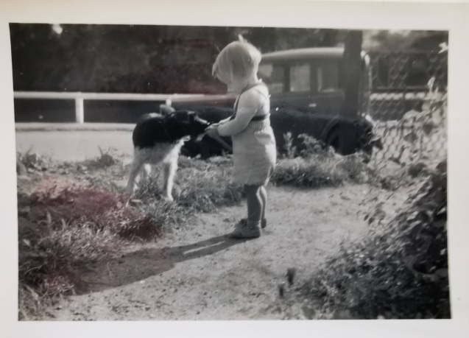

Figure Blue Austin Seven in 1958 with Jip

Navigation was by stored knowledge of a route, the towns passed through and landmarks, mostly public houses, on the way. No sat navs then, but we didn’t have to wait long before sitting down on 20 July 1969 to watch Neil Armstrong and Buzz Aldrin land on the moon with pinpoint precision thanks to support from NASA 240,000 miles away in Cape Canaveral.

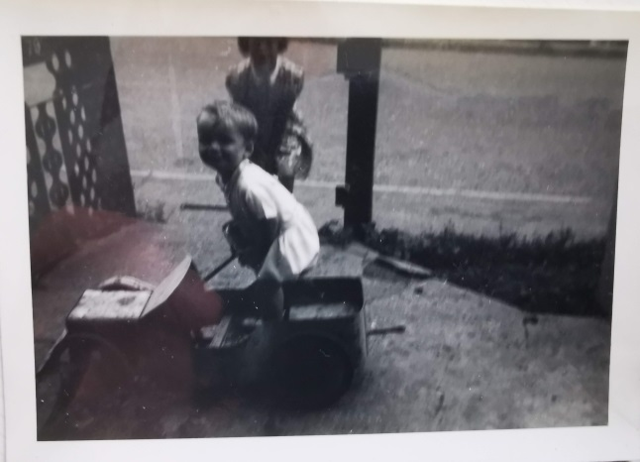

Figure Austin Seven replica pedal car made by Harold - painted blue with big sister Sue in attendance

On one occasion, reported and revisited frequently when relatives visited, we were coming back from somewhere through London. A scary trip at the best of times, but this was in the dark on unknown roads. Sleeping lengthways across the back seat, I was asleep for most of the journey, but awoke to the incensed frustrations of Jean complaining out loud, “That’s the third time we’ve seen Victoria!” I’m unsure if she meant the statue on the Mall, the bus station or somewhere else.

I say ‘could be available at weekends’ advisedly. For a mechanical engineer, car maintenance was essential to know and to learn. So I spent winters, too many to count, under the car bleeding brakes and using grease guns to pump grease into the axles. Then going topside to set tappets with feeler gauges, clean spark plugs , alter timing to top dead centre, decoking piston rods and rings, replacing head gaskets, replacing brake shoes, changing engine oil, oil and air filters and topping up brake fluid. Enough tasks to scatter throughout the year and keep me ‘out of mischief’ as he would say.

So, a break from all that was very welcome. One year when none was available, as the word holiday did not feature much, the kind neighbour Smithey mentioned he was going down to Lowestoft to a caravan he had there for a few days and would I like to come? I didn’t need asking twice and my parents agreed, because they trusted him and what’s more, Harold had helped maintain his car too! As neighbours you helped each other out and let’s face it, in a village that small, everyone’s your neighbour.

That must have been shortly after the lunar landing as the only detail I remember was that the caravan was parked on some short grass shoreline seascape with sharp drops occasionally where the tide once would have ventured, but no more. The sea air was refreshing and travelling further afield became an insatiable desire to venture outside the village.

The other curious visitor to the village from the outside world could only be glimpsed perhaps twice a year but once seen, never forgotten.

He was a large-framed man, well over six feet tall, who seemed well-suited to his profession as a travelling salesman, since he had to carry an enormous brown suitcase packed to the gunnels and fit to burst the substantial clasps keeping it closed.

Appearing as he did out of the blue, his bulk cast a shadow that filled the space between the door jambs. Realising he would need to duck down to enter and keep ducking if invited inside, he remained on the flagstones on the doorstep, kneeling down to open the clasps with the contents facing us. For a young child, this was temptation at its utmost that prompted gasps of amazement, for it was a panoply of coloured plastic kitchen and household items, brushes and scrubbing cloths, dishcloths and scrapers. Jean was drawn in too and soon the drainer had a new resident. He rarely left empty-handed.

Finding other people your own size never presented a problem for children in the village.

Friends were made down the rec and at school, especially at the end of term play performances, where the opportunity to be not yourself was enticing and entrancing in equal measure.

For one thing, it meant that primary school children were given access to the light blue coloured door up some steps on the right as you headed out of the schoolyard gate. Never knowing what it led to was part of its mystery initially and it went by the perplexing name of the PE room. That was odd because to my knowledge, no one ever had PE classes in there.

One the afternoon of dress rehearsals however, all was revealed. An army of volunteer make up mums, daughters in tow and seamstress adjusters positioned themselves behind three rows of trestle tables ready to draw faces with heavy eyebrows, moustaches and other face-painting delicacies to match the play’s theme.

After a bemused performance in *Royal Hunt of the Sun* dressed in a red tunic with nothing to say or do, I was glad the following year to be given the part, or shared part for one night out of the two, of Ping Pong in *Aladdin*.

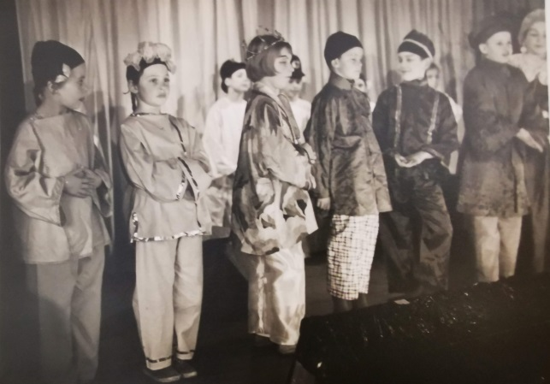

Figure : *Aladdin* production 1965 – Widow Twankey far right

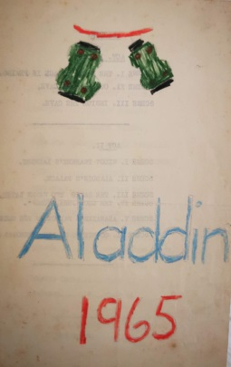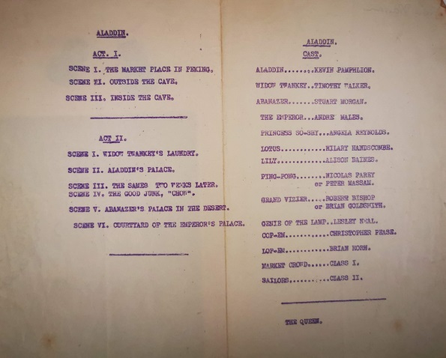

Figure *Aladdin* programme with cast list

Seemingly set in the Orient, his first action was to enter stage left not looking where he was going and run slap bang into Widow Twankey, played by the substantial and taller figure of Tim Walker. My slight frame rebounded off him, flinging me almost back off stage left. The audience collapsed with laughter. That sound was amazing and I could see why some would want to pursue that as a career years later.

The third and final play saw me take the lead but for one reason only: you had to be able sing out of tune! It was aptly named ‘*Singbad the Sailor’*. As a member of the church choir, it was thought that I could reliably do that on cue. From the sniggers, laughs and painful looks in the audience’s eyes I guess that desired effect was achieved.

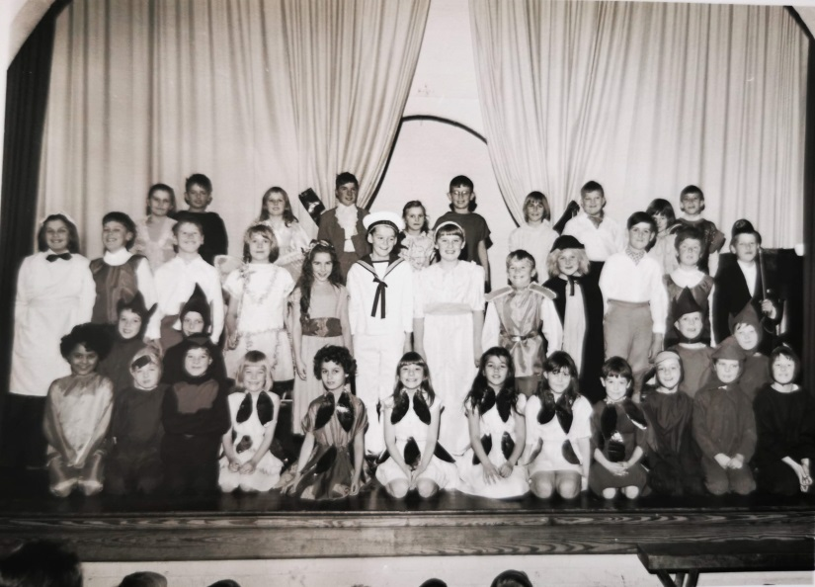

Figure Cast of ‘*Singbad the Sailor’* – Christmas 1967

Known Cast L to R:

Back Row: — — —Noel Walker — Colin Burton — Richard Allingham — —

Middle Row: — Nick Farey — — Melanie Horn Self Angela Reynolds Wayne Morgan — Melvyn Saggers Gary Mason —

Front Row: Caroline James (centre – 7 from left)

Other friendships formed, some longer, some shorter depending on personal circumstances. While it was clear I was not going anywhere soon, others had different schedules or plans to move out of the village. For example, the boy opposite, who lived in the large thatched cottage at the end of the road, went to Kingshott private school, so meeting occasionally became less frequent. Another, Andrew, featured with the improvised stocking fishing net above, was a firm friend but vanished without trace one summer.

Others who lived close-by like Noel Walker, Ken the farmer’s son on Hambridge Way, invited us to accompany him on the harvest trailers to witness the awesome combine harvester in action, emptying its wheat grains at our feet and the smell of hay, and later straw bales, full in our nostrils. The unloading was no less exciting and by the end of the day, we knew getting to sleep would not be a problem. Those kinds of adventures made childhood memories that last and for which we are eternally grateful.

***In Memoriam***

One other perspective from those days is the idea of travel.

As mentioned before, there was little need to venture further than Hitchin for most needs and that usually by bike or on the bus or by private motor car for longer journeys.

When asked if they had ever been abroad, the standard response was always “Yes, to the Isle of Wight for our honeymoon”.

It was popular because of its association with the late Queen Victoria and her preference to stay at Osbourne House, just as our later Queen Elizabeth preferred Balmoral perhaps.

Later in life Jean expressed the wish to go abroad but that did not happen. Not until my kind sister Sue organised for them both to go to Paris as a surprise gift.

There were two surprises from that. One, that Harold went along and never once thought about the garden and second, that Jean came back so animated and delighted that she had recalled some of her schoolgirl French with amazing clarity and made herself understood.

For a couple that had spent most of their lives together in the village at 79 High Street, it was fitting that this was their first excursion to foreign parts and was to be their last.

With gratitude from us all.

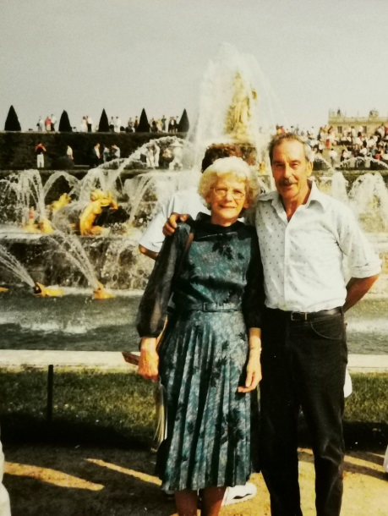

Figure Jean and Harold Massam in Versailles